

**HIVE CONNECT**

# MINI PROJECT REPORT

# (23EXC302)

***Submitted by***

**AMAL MANOJ**

## Register No: 717823Z106

**KRISHNAN N**

## Register No: 717823Z132

***in partial fulfillment for the award of the degree of***

**MASTER OF COMPUTER APPLICATIONS**

**SCHOOL OF COMPUTER APPLICATIONS**

**KARPAGAM COLLEGE OF ENGINEERING (AUTONOMOUS)**

**COIMBATORE**

**ANNA UNIVERSITY, CHENNAI**

**DECEMBER 2024**



**KARPAGAM COLLEGE OF ENGINEERING**

**COIMBATORE – 641 032**

**ANNA UNIVERSITY, CHENNAI**

**BONAFIDE CERTIFICATE**

Certified that this Report titled **“HIVE CONNECT”** is the bonafide work of **AMAL MANOJ (717823Z106)** and **KRISHNAN N (717823Z132)** who carried out the work under my supervision. Certified further that to the best of my knowledge the work reported here in does not form part of any other thesis or dissertation on the basis of which a degree or award was conferred on an earlier occasion on this or any other candidate.

|  |  |
| --- | --- |
| Signature of the Director with date  Dr. K. Anuradha  Director | Signature of the Supervisor with date  Dr. K. Anuradha  Director |
| School of Computer Applications  Karpagam College of Engineering  Coimbatore – 641 032 | School of Computer Applications  Karpagam College of Engineering  Coimbatore – 641 032 |

Certified that the candidate was examined during the viva voce examination held on _______

Signature of the Examiner - 1 with date Signature of the Examiner - 2 with date



**SCHOOL OF COMPUTER APPLICATIONS**

**VISION**

To be a nationally prominent and recognized department in academics and research activities with the aim of developing competent professionals to serve the society in the ever-changing industry.

**MISSION**

* Enabling the students to be knowledgeable and creative by developing state of the art curriculum and innovative teaching methods.
* Producing highly competent professionals by providing training programs to bridge the gap between the institution and industry.
* Enhancing the quality of research and productivity by providing the required facilities.



**PROGRAMME EDUCATIONAL OBJECTIVES**

* **PEO 1:** Graduates will be competent enough to identify, analyse, design and develop software solutions to the problems in the field.
* **PEO 2:** Graduates, equipped with good communication skills and technical expertise will be able to conceptualize and lead projects with an aim to become effective entrepreneurs or employees.
* **PEO 3:** Graduates, with exposure to highly active research environment, will have the motivation to participate and contribute in research and development.

**PROGRAMME OUTCOMES (POS)**

**STUDENTS IN THE MCA PROGRAMME WILL HAVE THE ABILITY TO**

1. Apply knowledge of computing fundamentals, computing specialization, mathematics, and domain knowledge appropriate for the computing specialization to the abstraction and conceptualization of computing models from defined problems and requirements.
2. Identify, formulate, research literature, and solve complex computing problems reaching substantiated conclusions using fundamental principles of mathematics, computing sciences, and relevant domain disciplines.
3. Design and evaluate solutions for complex computing problems, and design and evaluate systems, components, or processes that meet specified needs with appropriate consideration for public health and safety, cultural, societal, and environmental considerations.
4. Use research-based knowledge and research methods including design of experiments, analysis and interpretation of data, and synthesis of the information to provide valid conclusions.
5. Create, select, adapt and apply appropriate techniques, resources, and modern computing tools to complex computing activities, with an understanding of the limitations.
6. Understand and commit to professional ethics and cyber regulations, responsibilities, and norms of professional computing practices.
7. Recognize the need, and have the ability, to engage in independent learning for continual development as a computing professional.
8. Demonstrate knowledge and understanding of the computing and management principles and apply these to one’s own work, as a member and leader in a team, to manage projects and in multidisciplinary environments.
9. Communicate effectively with the computing community, and with society at large, about complex computing activities by being able to comprehend and write effective reports, design documentation, make effective presentations, and give and understand clear instructions.
10. Understand and assess societal, environmental, health, safety, legal, and cultural issues within local and global contexts, and the consequential responsibilities relevant to professional computing practices.
11. Function effectively as an individual and as a member or leader in diverse teams and in multidisciplinary environments.
12. Identify a timely opportunity and using innovation to pursue that opportunity to create value and wealth for the betterment of the individual and society at large.

# 

# DECLARATION

I hereby declare that this Project report entitled “**HIVE CONNECT**” submitted by us for the degree of **Master of Computer Applications at Karpagam College of Engineering**, **Coimbatore** is the record of original work done by us under the guidance and supervision of **Dr. K. Anuradha, Director** at the School of Computer Applications, Karpagam College of Engineering, Coimbatore – 641032 and has not formed the basis for the award of any degree, or diploma or titles in this Institution or any other Institution of higher learning.

(Signature of the Candidate 1)

**AMAL MANOJ – 717823Z106**

Date : (Signature of the Candidate 2)

Place : Coimbatore **KRISHNAN N – 717823Z132**

i

# ACKNOWLEDGMENT

**First and foremost praises and thanks to the almighty for her showers and blessings throughout my project work to complete it successfully.**

I extend my gratitude to the Management of Karpagam College of Engineering, Coimbatore for the excellent infrastructure and support facilities to undergo the project work.

I am very grateful to Dr. V. Kumar Chinnaiyan, the Principal and   
**Dr. K. ANURADHA**, **Director, School of Computer Applications** for provided the facilities, support and permission to carried out my project work at our esteemed institution.

I record my sincere gratitude to my Project Coordinator   
**Mr. R. RAMPRASHATH, Assistant Professor** for giving inputs, encouragement for the continuous improvement during the progress and to complete this project work.

I would like to express my sincere gratitude to my Project Supervisor   
**Dr. K. ANURADHA**, **Director** for the continuous support for my PG study, for her motivation and adequate guidance which helped me to achieve success in all my accomplishments and to complete this project work.

I also thank all the teaching faculty members and non-teaching Staff members of the department of **School of Computer Applications**, Karpagam College of Engineering, Coimbatore for their kindness and support.

I would like to thank **my parents, family members and friends** who sacrificed their time and energy to complete the project work successfully.

**AMAL MANOJ**

**KRISHNAN N**

ii

# ABSTRACT

**Hive Connect** is a web-based application designed to streamline the process of finding reliable and skilled local service providers. Whether it's a maid, tuition teacher, plumber, electrician, or any other service, Hive Connect enables users to quickly discover service professionals within their locality. The primary goal of Hive Connect is to provide a centralized platform that allows users to search for, connect with, and review local service providers, while also enabling service providers to manage their profiles and services effectively.

The system is built to record, store, and update service provider information systematically, ensuring that all listings are accurate and up-to-date. By utilizing a user-friendly search engine, Hive Connect allows users to filter through various service categories, compare options, and make informed decisions based on service provider ratings, availability, and proximity. The platform also facilitates the continuous management of service provider records, allowing businesses to maintain and update their listings in real time.

iii

**TABLE OF CONTENTS**

|  |  |  |
| --- | --- | --- |
| **CHAPTER.NO.** | **TITLE** | **PAGE.NO** |
|  | **DECLARATION**  **ACKNOWLEDGEMENT**  **ABSTRACT** | **i**  **ii**  **iii** |
|  | **TABLE OF CONTENTS** | **iv** |
|  | **LIST OF TABLES** | **vii** |
|  | **LIST OF FIGURES** | **viii** |
| **1** | **INTRODUCTION**   * 1. OBJECTIVES | **1**  2 |
| **2** | **SYSTEM ANALYSIS**   * 1. EXISTING SYSTEM      1. Challenges of Existing System   2. PROPOSED SYSTEM      1. Scope and Features   3. FEASIBILITY STUDY      1. Economic Feasibility      2. Technical Feasibility      3. Operational Feasibility | **3**  3  3  5  5  7  7  7  7 |
| **3** | **SYSTEM SPECIFICATION**   * 1. HARDWARE REQUIREMENT   2. SOFTWARE REQUIREMENT | **8**  8  8 |

iv

|  |  |  |
| --- | --- | --- |
| **4** | **SOFTWARE DESCRIPTION**   * 1. ABOUT THE SOFTWARE   2. FRONT END      1. HTML      2. JAVASCRIPT         1. Features of JavaScript      3. PHP         1. Features of PHP   3. BACKEND      1. MYSQL         1. Features of MYSQL | **9**  9  9  9  10  10  11  11  12  12  12 |
| **5** | **PROJECT DESCRIPTION**   * 1. PROBLEM DEFINITION   2. OVERVIEW OF THE PROJECT   3. MODULE DESCRIPTION      1. ADMIN MODULE      2. USER MODULE | **13**  13  13  15  15  16 |
| **6** | **SYSTEM DESIGN AND DEVELOPMENT**   * 1. USE CASE DIAGRAM   2. ER DIAGRAM   3. DATA FLOW DIAGRAM   4. DATABASE DESIGN | **17**  17  18  19  20 |

v

|  |  |  |
| --- | --- | --- |
| **7** | **TESTING AND IMPLEMENTATION**   * 1. TESTING   2. EXPECTED AND ACTUAL RESULT ADMIN MODULE | **21**  21  22 |
| **8** | **CONCLUSION & FUTURE ENHANCEMENT**   * 1. CONCLUSION   2. FUTURE ENHANCEMENT | **23**  23  24 |
| **9**  **10** | **APPENDICES**   * 1. SOURCE CODE   2. SCREEN SHOTS   **REFERENCES** | **25**  25  29  **32** |

vi

**LIST OF TABLES**

|  |  |  |
| --- | --- | --- |
| **CHAPTER.NO.** | **TITLE** | **PAGE.NO** |
| **6** | **DATABASE DESIGN**   * + 1. ADMIN TABLE     2. CATEGORIES TABLE     3. PERSON TABLE     4. PAGE TABLE | **16**  16  16  16  16 |
| **7** | **TESTING AND IMPLEMENTATION**   * + 1. TEST CASE FOR ADMIN TABLE | **17**  18 |

vii

**LIST OF FIGURES**

|  |  |  |
| --- | --- | --- |
| **CHAPTER.NO.** | **TITLE** | **PAGE.NO** |
| **6** | **SYSTEM DESIGN AND DEVELOPMENT**   * 1. USE CASE DIAGRAM   2. ER DIAGRAM   3. Data Flow Diagram | **14**  14  15  16 |
| **9** | **SCREENSHOTS**   * + 1. HOME PAGE     2. CATEGORIES PAGE     3. ADMIN LOGIN PAGE     4. ADMIN DASHBOARD PAGE     5. ADMIN MANAGE CATEGORY     6. ADMIN MANAGE PEOPLE | **25**  25  25  26  26  27  27 |

viii

**CHAPTER 1**

**INTRODUCTION**

Hive Connect is a dynamic, web-based platform designed to streamline and enhance connectivity among various service providers and users within a local community. Unlike traditional service directories, Hive Connect emphasizes creating an interconnected network where users can easily discover, contact, and manage services ranging from skilled professionals like electricians and tutors to local businesses offering specialized expertise. By serving as a centralized hub for community services, Hive Connect aims to simplify the process of finding reliable services while fostering a collaborative local ecosystem.

The system comprises two core modules: the Admin Module and the User Module. Through the Admin Module, administrators can oversee service categories, maintain provider records, and manage system settings to ensure that all information remains accurate and accessible. The User Module provides end-users with a straightforward interface to explore available services, view provider profiles, and establish direct contact, thereby reducing the barriers to accessing local resources efficiently.

Hive Connect is more than just a search tool; it is a community-focused platform designed to strengthen local connectivity. By leveraging Hive Connect, users benefit from an organized, automated solution that enhances service accessibility, promotes local engagement, and builds a robust support network within their community.

* 1. **OBJECTIVES**

1. **Facilitate Local Service Discovery**: Provide users with an easy-to-use platform for discovering and connecting with local service providers, including a range of professionals and businesses within their community.
2. **Streamline Communication**: Simplify the communication process between users and service providers by offering direct contact options, making it easier to arrange appointments and discuss service needs.
3. **Enhance Data Management for Administrators**: Enable administrators to efficiently manage service categories, provider profiles, and user information, ensuring that all data is accurate, current, and easily accessible.
4. **Promote Community Engagement**: Foster a sense of community by connecting local users with neighborhood resources, supporting local businesses, and encouraging community interactions.
5. **Ensure Data Security and User Privacy**: Prioritize secure data handling practices to protect user information and privacy, ensuring that personal details and interactions remain confidential.
6. **Optimize User Experience**: Offer a responsive, intuitive user interface that provides seamless navigation and access to resources, enhancing the overall user experience on both mobile and desktop devices.
7. **Automate Service Management Processes**: Minimize manual administrative tasks by automating data updates, user management, and service categorization, allowing administrators to focus on service quality and community support.

**CHAPTER 2 SYSTEM ANALYSIS**

* 1. **EXISTING SYSTEM**

Traditionally, finding local service providers such as plumbers, electricians, tutors, or cleaners has relied on a mix of informal networks and generalized platforms. Users commonly turn to personal recommendations from friends and family, neighborhood bulletin boards, and local advertisements in print or online. In addition, many people use general search engines or larger online service directories to locate professionals in their area.

Some communities may also have small-scale websites or social media groups dedicated to local services, where providers can advertise their expertise and users can post requests for recommendations. These platforms sometimes facilitate direct communication between users and service providers, allowing users to gather quotes, discuss service details, and arrange appointments.

While these methods offer several avenues for discovering local services, they typically function independently, each serving different segments of the community and offering varying levels of detail and interaction. As a result, users and providers have multiple options to connect, though the overall experience and range of available resources can vary.

## Challenges of the Existing System

1. **Fragmented Access to Providers**: With multiple, unconnected platforms and informal networks, users face difficulties in accessing a comprehensive list of available local service providers. This fragmentation often means users are unaware of all possible options in their area.
2. **Lack of Centralized Information**: Existing systems lack a single, reliable database for managing provider details. This leads to inconsistent information, making it hard for users to find accurate and up-to-date profiles or for providers to showcase their full range of services effectively.
3. **Time-Consuming Search and Selection Process**: Without a streamlined platform, users often need to spend time contacting multiple providers individually to gather information, compare rates, and verify availability, which can delay the process of securing the needed service.
4. **Limited Communication and Interaction**: Many traditional systems lack tools for efficient communication between users and providers, leading to missed inquiries, delayed responses, or confusion over service details, which can discourage both parties.
5. **Inconsistent Quality Control**: It is challenging for users to assess the quality and reliability of service providers without user reviews, ratings, or transparent provider histories, which many existing platforms fail to offer. This lack of quality indicators creates uncertainty and may lead to unsatisfactory service experiences.
6. **Privacy and Security Risks**: Users may have concerns about sharing personal contact information on multiple platforms, especially where privacy policies and data security practices are unclear or vary widely among local service directories and online platforms.
   1. **PROPOSED SYSTEM**

The proposed Hive Connect platform seeks to establish a centralized, efficient, and user-friendly system that redefines how local services are discovered, managed, and delivered. By integrating various service providers and users into one cohesive platform, Hive Connect aims to simplify the process of finding and interacting with local professionals. This system will enable users to easily connect with service providers based on their needs and location, fostering a more connected and efficient local service ecosystem.

Unlike traditional systems, which often rely on fragmented approaches to service discovery, Hive Connect will offer a streamlined experience where users can quickly access relevant, accurate, and up-to-date information. The platform will provide administrators with the tools to manage service categories, maintain provider profiles, and ensure that data remains organized and reliable. For users, it will offer an intuitive interface that simplifies the search and communication process, ensuring that the right service providers can be found with minimal effort.

Hive Connect will emphasize security, privacy, and ease of use, ensuring that both users and service providers can trust the platform to handle their interactions and data securely.

## Scope and Features

The scope of Hive Connect extends to several key areas aimed at improving the local service discovery and delivery process:

1. **Local Service Discovery**: Hive Connect will serve as a comprehensive platform for users to discover a wide variety of local services, from home repairs to personal tutoring, all organized into easily navigable categories.
2. **Community Engagement**: The platform will support local businesses and service providers, fostering community engagement and promoting the use of local resources. Hive Connect will act as a network that strengthens relationships within the community, creating a reliable and efficient service marketplace.
3. **User-Centric Platform**: Hive Connect will cater to end-users by providing a simple and accessible interface for browsing services, viewing provider profiles, and directly contacting providers, ensuring that users can find and connect with the services they need with ease.
4. **Provider Management**: The system will offer tools for service providers to create and manage their profiles, ensuring they are accurately represented on the platform and that users can easily find them based on the services they offer.
5. **Secure Transactions and Data Privacy**: Hive Connect will ensure that user and provider data is kept secure, with clear privacy policies and safe methods for communication and transaction handling.
6. **Scalability and Future Expansion**: The platform is designed to be scalable, allowing it to grow with increasing users, services, and geographical regions. Future enhancements may include additional services or integrations with other platforms to expand Hive Connect’s functionality.
   1. **FEASIBILITY STUDY**

A feasibility study is essential to determine whether Hive Connect, as a platform for connecting users and local service providers, can be effectively developed and implemented. The feasibility of Hive Connect is evaluated across four primary dimensions: technical, operational, economic, and legal.

* Economic Feasibility
* Technical Feasibility
* Operational Feasibility

## Economic Feasibility

Economic feasibility considers the cost of developing, implementing, and maintaining Hive Connect, alongside its expected return on investment (ROI). A detailed financial analysis is required to ensure the platform’s profitability.

## Technical Feasibility

The technical feasibility of Hive Connect depends on the availability of the necessary technological resources, development tools, and infrastructure. The platform requires a robust web and mobile application, a secure and scalable backend system, and an intuitive user interface to ensure a seamless user experience

## Operational Feasibility

Operational feasibility assesses whether the proposed system aligns with the organization’s goals and operations. Hive Connect aims to improve local service discovery, communication, and data management, which aligns with the needs of users and service providers.

**CHAPTER 3 SYSTEM SPECIFICATION**

* 1. **HARDWARE REQUIREMENTS**
     + **Processor :** i3 Processor
     + **Hard Disk :** 512 GB
     + **Monitor :**16” Colour Monitor
     + **RAM :** 4 GB or Above
  2. **SOFTWARE REQUIREMENTS**
     + **Operating System :** Windows 10
     + **Front End :** HTML, CSS, JavaScript

### Server Side Language : PHP

* + - **Database :** MySQL
    - **Web server :** XAMPP Server
    - **IDE :** Visual Studio Code

**CHAPTER 4 SOFTWARE DESCRIPTION**

* 1. **ABOUT THE SOFTWARE**

Software selection is an important work in a project development cycle. Software must be selected in accordance with the application and the latest technology available. My choice is PHP, HTML, JAVASCRIPT as Front end, MYSQL as back end, an XAMPP web server. XAMPP is a free and open-source cross-platform web server solution stack package developed by Apache Friends, consisting mainly of the Apache HTTP Server, Maria DB database, and interpreters for scripts written in the PHP.

* 1. **FRONT END**
     1. **HTML**

Hyper Text Markup Language is a scripting language used for writing data in web pages.HTML plays a crucial role in building the user interface for various aspects of survey management. For example, it enables the creation of user-friendly web forms for administrators to create, modify, and schedule surveys with ease. HTML is also used to provide customization options for different question types, including multiple-choice, open-ended, and rating scales, ensuring that surveys can be tailored to specific needs. Additionally, HTML is employed for user authentication, enabling secure access to the survey management module. It facilitates the design of interfaces for survey distribution, response collection, result presentation, and user dashboards, making the entire survey management process more efficient and user-friendly. When combined with CSS for styling and JavaScript for interactivity, HTML forms the foundation of the project's frontend, enhancing the user experience for both administrators and participants. .

* + 1. **JAVASCRIPT**

JavaScript is a pivotal component in this project, enhancing the survey management system's functionality and interactivity. It enables dynamic elements for survey creation, modification, and real-time previews. JavaScript enhances user experience with interactive scheduling, user authentication, and responsive distribution interfaces. It provides real-time validation and error handling for participant feedback. Dynamic charts and graphs visualize survey results, while interactive dashboards simplify survey management. In collaboration with HTML and CSS, JavaScript makes the system more efficient and user-friendly, improving both administrator and participant experiences.

## Features of JavaScript

**Form Validation:** JavaScript can be used to perform client-side form validation to ensure that participants provide valid responses in real-time, reducing the likelihood of incorrect or incomplete data**.**

**Dynamic Form Elements:** It enables the creation of dynamic forms with elements that appear or disappear based on user inputs, allowing for more user-friendly and responsive survey designs.

**Interactivity:** It enhances the user experience by adding interactive elements like drag-and- drop features, dynamic pop-ups, and real-time updates, making the survey management system more engaging and efficient.

**Error Handling**: JavaScript can provide user-friendly error messages and notifications to guide participants and administrators through the survey process, reducing confusion and frustration**.**

**AJAX (Asynchronous JavaScript and XML):** AJAX can be used to fetch data from the server without requiring a full page reload. This can be valuable for real-time updates, such as notifying participants when new surveys are available or showing responses as they come in.

**Responsive Design:** JavaScript can be used in conjunction with CSS to create responsive designs that adapt to different screen sizes and devices, ensuring a consistent user experience.

* + 1. **PHP**

PHP is a fundamental component, serving a crucial role on the server-side. It manages data storage, user authentication, and dynamic content generation. PHP processes and validates survey responses, calculates results, and handles email notifications, ensuring efficient communication. It also maintains user sessions, integrates with external services, and manages file uploads. Security measures, such as server-side validation and protection against web vulnerabilities, are implemented. Additionally, PHP automates survey scheduling and generates reports in various formats. Collaborating with client-side technologies, it forms a robust survey management system, enabling data storage, processing, and secure communication.

* + - 1. **FEATURES OF PHP**

**Database Integration:** PHP can connect to a database to store and retrieve survey-related data, such as user profiles, survey questions, responses, and schedules. This feature ensures data is organized and accessible.

**User Authentication:** PHP manages user authentication, verifying the credentials of administrators to secure access to the survey management system, maintaining data security.

**Data Processing:** PHP processes and validates survey responses on the server-side, ensuring data integrity, accuracy, and consistency, which is crucial for reliable survey data.

**Dynamic Content Generation:** PHP can dynamically generate HTML content based on user interactions and database queries, allowing for the creation of dynamic survey forms, result pages, and reports, improving user experience.

**Server-Side Validation:** PHP performs server-side validation of form data to enhance security and prevent unauthorized or malicious input, ensuring data quality.

.

* 1. **BACKEND**
     1. **MYSQL**

As the project aims to derive meaningful insights from survey data, MySQL's capabilities in efficient data retrieval play a pivotal role. Its query optimization features streamline the process, facilitating in-depth analysis and timely extraction of valuable information. Ensuring data integrity is paramount, and MySQL's support for constraints and transactions proves invaluable in maintaining the accuracy and consistency of survey data.With the project's growth in mind, MySQL's scalability features allow the system to seamlessly adapt to an increasing volume of survey responses, accommodating the evolving dataset. Security is paramount in handling sensitive survey data, and MySQL's robust measures, including user authentication, access controls, and encryption, safeguard the confidentiality of information, aligning with stringent data privacy standards.

## Features of MYSQL

**Data Storage and Organization:** MySQL is employed to systematically store and organize survey-related data in a relational database structure. This ensures a well- structured and efficient repository for survey responses.

**Data Retrieval for Analysis:** The project utilizes MySQL's capabilities for efficient data retrieval, crucial for conducting in-depth analysis and generating meaningful insights from the collected survey data.

**Data Integrity and Accuracy:** MySQL's support for constraints and transactions ensures the integrity of survey data, preventing inconsistencies and errors that could compromise the accuracy of analysis and interpretation.

**Transaction Support for Data Consistency:** MySQL's transaction support is instrumental in maintaining data consistency during various operations, ensuring that survey-related transactions are executed reliably as atomic units.

**Indexing for Quick Data Access :** Indexing features in MySQL enhance the speed of data access, particularly valuable when conducting complex queries and analyses on extensive survey datasets.

**CHAPTER 5 PROJECT DESCRIPTION**

* 1. **PROBLEM DEFINITION**

The process of connecting users with local service providers, such as technicians, tutors, or healthcare professionals, has traditionally been fragmented. Users often face difficulty in quickly identifying reliable service providers in their vicinity. The lack of a centralized platform for local service management results in users spending significant time searching for providers, reaching out to multiple contacts, and comparing options across various informal channels.

In addition, local service providers, especially smaller businesses, struggle to gain visibility in their communities and connect with potential customers. The absence of an organized, easily accessible platform means these providers often rely on word-of-mouth or traditional advertising methods, which may not always be effective or reach the right audience.

To address these challenges, a platform like Hive Connect is needed—one that brings together both users and service providers in a centralized, efficient system, making it easier to search, communicate, and interact. Hive Connect aims to bridge the gap between users' service needs and the providers who can fulfill them, creating a more streamlined and accessible environment for local service management.

* 1. **OVERVIEW OF THE PROJECT**

Hive Connect is an innovative web-based platform designed to bridge the gap between local service providers and users in a community. It offers an intuitive and seamless way for users to discover, connect, and manage services ranging from home repairs and tutoring to specialized business solutions. The platform serves as a centralized hub where users can find trusted professionals within their locality, view detailed profiles, and directly engage with service providers.

The project is built on two core modules: the Admin Module and the User Module.

* Admin Module: This module is designed for administrators to manage the backend operations of the platform. It includes the ability to update and maintain service categories, add and manage provider profiles, and monitor system activity. Administrators also have control over the platform's content, such as managing pages like “About Us” and “Contact Us.”
* User Module: The User Module provides an easy-to-navigate interface for end-users to search for local service providers. Users can browse different categories, view detailed provider profiles, and contact providers directly to inquire about services, schedule appointments, or request quotes.

The primary aim of Hive Connect is to improve the way users access and manage local services by creating a comprehensive and user-friendly platform that centralizes all information in one place. The system is designed with simplicity and efficiency in mind, ensuring that both users and providers can easily find, interact with, and manage services. By automating the search process, enhancing communication, and enabling easy updates to provider information, Hive Connect transforms how local services are delivered and experienced.

The platform is built to be secure, reliable, and scalable, offering a solution that can adapt to the growing needs of local communities while providing an excellent user experience

* 1. **MODULE DESCRIPTION**
     1. **ADMIN MODULE:**

The Admin Module provides administrators with the tools necessary to manage and control all aspects of the Hive Connect platform. The main functions of the Admin Module include:

* Dashboard: The admin can access a comprehensive dashboard that provides a summary of key platform metrics, such as the number of registered users, active service providers, and available service categories. This overview helps admins monitor the platform’s performance and user engagement.
* Service Management: Admins can manage service categories, adding or removing categories based on user demand or new service trends. They can also update existing categories to ensure they reflect the most accurate and relevant services available.
* Provider Management: This function allows administrators to add, update, or remove service providers from the platform. Admins can verify provider credentials, update their profiles, and ensure that all listed providers meet platform standards.
* User Management: Admins can view and manage user accounts, track activity, and handle user requests or issues. The ability to monitor user interactions ensures that the platform remains secure and that users are engaging with the system appropriately.
* Reporting & Analytics: Admins can generate reports related to platform usage, user behavior, service provider performance, and other analytics that help with decision-making and future platform improvements.
* System Settings: Administrators can configure platform settings, such as user roles, security parameters, and system notifications. This ensures the system remains flexible and customizable to meet the evolving needs of users and service providers.
  + 1. **USER MODULE:**

The User Module allows end-users to interact with the Hive Connect platform, discover services, connect with service providers, and manage their personal profiles. Key features of the User Module include:

* User Dashboard: Upon logging in, users are presented with a personalized dashboard that displays service categories, recommended providers, recent searches, and notifications. This dashboard is designed to make it easy for users to navigate the platform and find the services they need.
* Service Search: Users can search for local service providers by category, location, or specific service keywords. The search feature is designed to be intuitive and fast, allowing users to easily find providers that match their needs.
* Provider Profiles: Each service provider on the platform has a dedicated profile that includes their qualifications, services offered, pricing information, customer reviews, and contact details. Users can browse these profiles to make informed decisions about which provider to hire.
* Direct Communication: Users can contact service providers directly through messaging or calling features built into the platform. This streamlines the process of arranging appointments, discussing service details, or asking questions.
* Reviews and Ratings: After using a service, users can leave reviews and ratings for service providers. This helps future users make more informed decisions and allows providers to receive feedback to improve their services.
* User Profile Management: Users can manage their personal information, update contact details, track past services, and view their interactions with service providers. This section ensures users can stay organized and maintain control over their account.
* Notifications and Alerts: Users receive notifications about service availability, updates from their service providers, promotional offers, or changes in system functionality. This ensures users stay informed and engaged with the platform.

**CHAPTER 6**

**SYSTEM DESIGN AND DEVELOPMENT**

* 1. **USE CASE DIAGRAM**

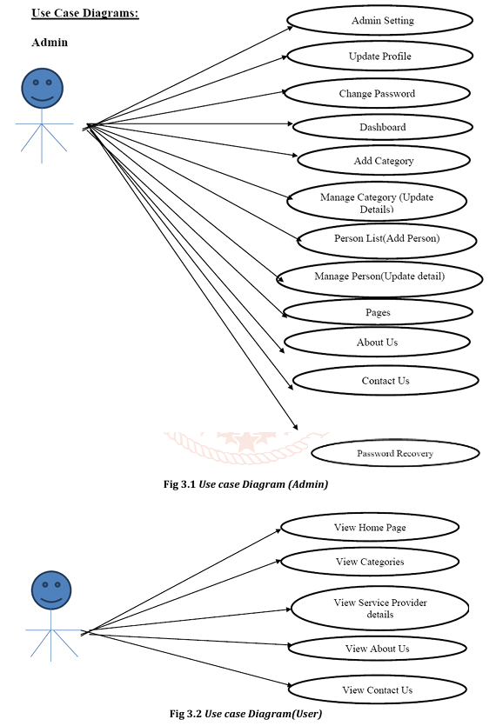

Figure 6.1.1 Use case Diagram

* 1. **ER DIAGRAM**

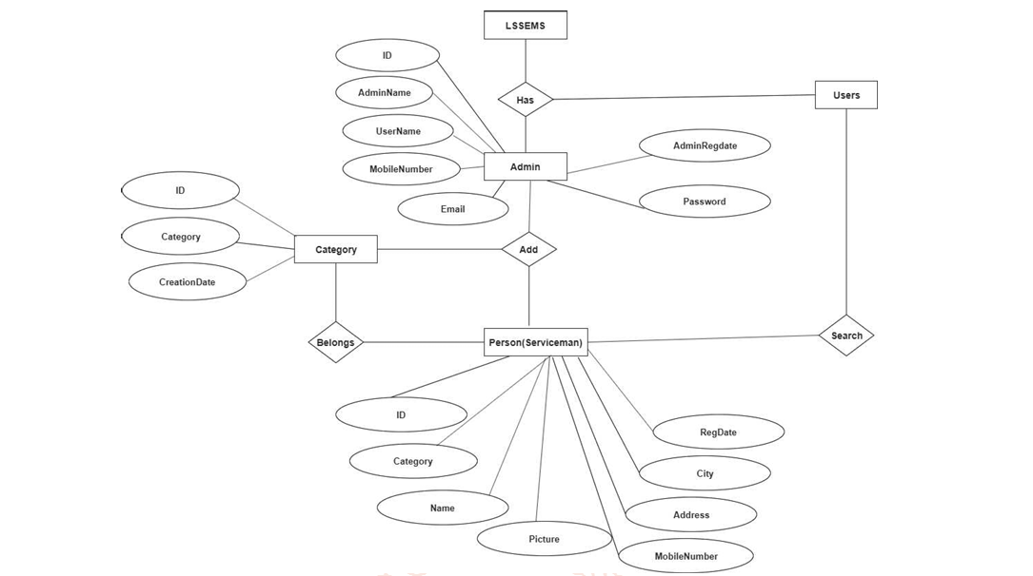

Figure 6.2.1 ER Diagram

* 1. **Data Flow Diagram**

**DFD Level – 0**

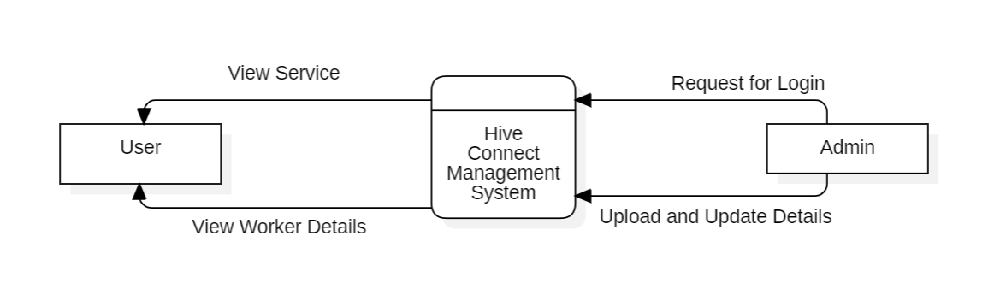

Figure 6.3.1 DFD Level 0

**DFD Level – 1**

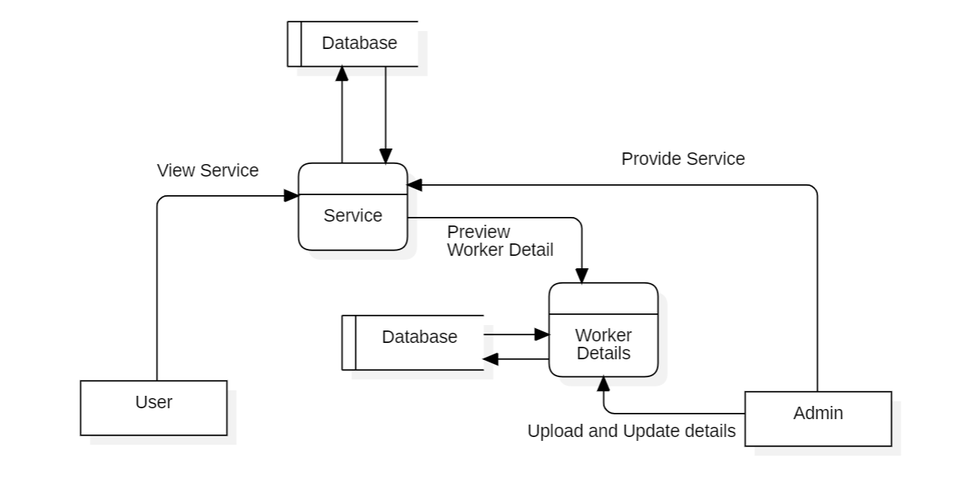

Figure 6.3.2 DFD Level 1

* 1. **DATABASE DESIGN**

### Table structure:

Table name: Admin Table Primary key: ADMIN_ID

Description.: To store the admin details

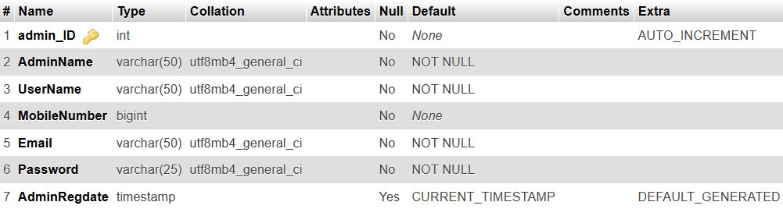

Table 6.3.1 Admin Table

### Table structure:

Table name: Category Table Primary key: CATEGORY_ID

Description: To store the category details

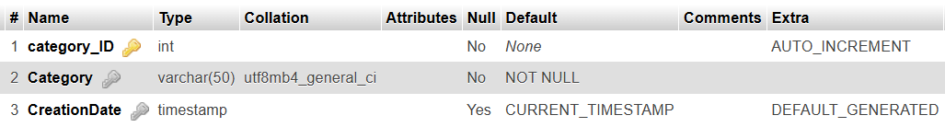

Table 6.3.2 Category Table

### Table structure:

Table name: Person Table Primary key: Person_ID

Description: To store the person details

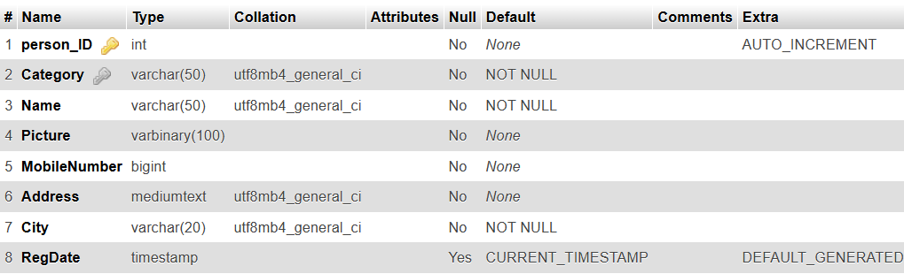

Table 6.3.3 Person Table

### Table structure:

Table name: Page Table Primary key: Page_ID

Description: To store the page details

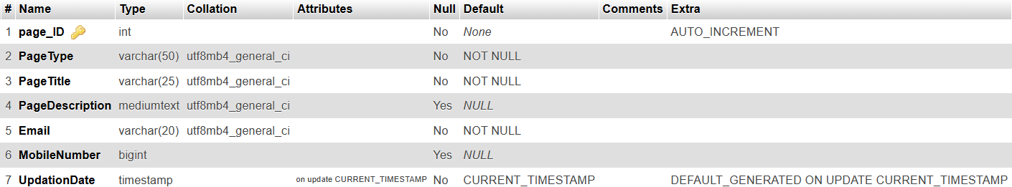

Table 6.3.4 Page Table

**CHAPTER 7**

**TESTING AND IMPLEMENTATION**

* 1. **TESTING**
     + Unit Testing
     + System Testing
     + Integration Testing

### Unit Testing:

**Purpose:** Unit testing involves testing individual components or functions in isolation to ensure that they work as expected. This is the foundation of testing, and it helps catch bugs and issues at an early stage.

**Scope:** You can perform unit testing on backend functions responsible for tasks like data processing, user authentication, and database interactions.

### System Testing:

**Purpose:** System testing evaluates the entire system to verify that it meets the project's requirements and functions correctly as a whole. This includes testing the interactions between different components and modules.

**Scope:** System testing can focus on ensuring that all survey management processes work seamlessly, from data collection to analysis and reporting.

### Integration Testing:

**Purpose:** Integration testing checks the interactions between different modules or components to identify and rectify any issues related to data flow and communication between them.

**Scope:** Integration testing is crucial for ensuring that data is properly transferred between the frontend and backend components, user authentication functions work as expected, and that the data analysis modules interact correctly with the database.

* 1. **TEST CASE FOR ADMIN MODULE**

|  |  |  |  |  |  |
| --- | --- | --- | --- | --- | --- |
| **SNO** | **TEST CONDITION** | **EXPECTED RESULT** | **ACTUAL RESULT** | **STATUS** | **COMMENTS** |
| 1. | Enter the valid username and password  Of the admin | Control should take the user to the respective page | Control takes the user to the respective page | Pass | Positive scenario |
| 2**.** | Enter the right user ID and wrong password. | Error message should displayed | Error | Pass | Negative scenario |
| 3. | Enter the  wrong user and password | Error message will be displayed | Error | Pass | Negative Scenario |

Table 7.2.1 Test Case

**CHAPTER 8**

**CONCLUSION & FUTURE ENHANCEMENT**

* 1. **CONCLUSION**

In conclusion, the " Hive Connect " project, tailored for colleges, stands as a valuable asset for educational institutions.

Hive Connect provides an innovative solution to the traditional methods of discovering and connecting with local service providers. By offering a centralized, user-friendly platform, Hive Connect enhances the accessibility and efficiency of finding and managing local services. The system not only streamlines the communication between users and service providers but also ensures that data is well-organized and up-to-date, fostering trust and reliability within the community.

Through its intuitive interface and automated management tools, Hive Connect simplifies the process for both users and administrators, reducing manual work and improving service delivery. This centralized approach helps to create a more connected, engaged local community, offering a valuable resource for users and service providers alike.

As Hive Connect continues to grow and evolve, its ability to support local businesses and service providers in a more efficient, secure, and engaging manner will set it apart from other solutions.

In summary, the " Hive Connect " project is a significant contribution to the world of higher education, providing colleges with the tools to gather meaningful insights from survey data and drive informed decision-making.

* 1. **FUTURE ENHANCEMENT**

While Hive Connect offers a comprehensive platform for local service management, there are several areas for future enhancement that could further improve its functionality and reach:

* **Integration with Smart Devices**: Expanding Hive Connect to work with IoT (Internet of Things) devices could enable users to monitor and control services in real-time, such as scheduling maintenance for smart appliances or receiving notifications for service updates.
* **Advanced Search and Recommendation System**: Incorporating AI-driven algorithms could help users discover services based on their preferences, location, or past behavior. Personalized recommendations would make it easier for users to find the most relevant service providers quickly.
* **Rating and Review System**: Implementing a rating and review system would allow users to share their experiences with service providers. This would increase transparency, helping others make informed decisions and allowing providers to improve their services based on feedback.
* **Mobile App Development**: While the platform is currently web-based, developing a mobile app would provide users with greater flexibility to search for services, make appointments, and interact with service providers while on the go.
* **Expanded Payment Integration**: Adding secure, integrated payment options would allow users to pay for services directly through the platform, improving convenience for both users and service providers.
* **Community Features**: Including features like forums, local events, or community groups could further promote interaction within the local community, allowing users to share experiences, offer advice, and support local businesses.
* **Multilingual Support**: Expanding language options would make Hive Connect accessible to a wider audience, accommodating users from diverse backgrounds and locations.

These future enhancements will not only refine the user experience but also position Hive Connect as a comprehensive, all-encompassing platform for local services and community building.

**CHAPTER 9 APPENDICES**

* 1. **SOURCE CODE**

## INDEX.php

<?php

session_start();

error_reporting(0);

include('includes/dbconnection.php');

?>

<!DOCTYPE html>

<html>

<head>

    <title>HiveConnect|| Home Page</title>

    <link rel="stylesheet" type="text/css" href="bootstrap/css/bootstrap.min.css">

    <link rel="stylesheet" type="text/css" href="css/style.css">

    <link rel="stylesheet" type="text/css" href="css/menu.css">

    <link rel="stylesheet" type="text/css" href="css/color/color.css">

    <link rel="stylesheet" type="text/css" href="assets/testimonial/css/style.css" />

    <link rel="stylesheet" type="text/css" href="assets/testimonial/css/elastislide.css" />

    <link rel="stylesheet" type="text/css" href="css/responsive.css">

     <link rel="stylesheet" type="text/css" href="css/font-awesome.css">

    <link rel='stylesheet' type='text/css' href='https://fonts.googleapis.com/css?family=Montserrat:400,700|Lato:300,400,700,900'>

    <link rel="stylesheet" type="text/css" href="assets/revolution_slider/css/revslider.css" media="screen" />

</head>

<body>

    <div class="preloader"><span class="preloader-gif"></span></div>

    <div class="theme-wrap clearfix">

        <div class="wsmenucontent overlapblackbg"></div>

        <div class="wsmenuexpandermain slideRight">

            <a id="navToggle" class="animated-arrow slideLeft"><span></span></a>

            <a href="#" class="smallogo"><img src="images/logo.png" width="120" alt="" /></a>

        </div>

        <?php include_once('includes/header.php');?>

        <section id="slider-revolution">

            <div class="fullwidthbanner-container">

                <div class="revolution-slider tx-center">

                    <ul><!-- SLIDE  -->

                        <!-- Slide1 -->

                        <li data-transition="slideright" data-slotamount="5" data-masterspeed="1000">

                        <!-- MAIN IMAGE -->

                            <img src="images/mnpower.jpg" alt="item slide">

                        </li>

                    </ul>

                </div>

            </div>

        </section>

        <section id="search-form">

            <div class="container">

                <div class="search-form-wrap">

                    <form class="clearfix" name="search" action="serviceman-search.php" method="post">

                        <div class="select-field-wrap pull-left">

                            <input class="input-field" type="text" placeholder="Location" name="location" style="height:55px;" required="required">

                            </select>

                        </div>

                        <div class="select-field-wrap pull-left">

                            <select class="search-form-select" name="categories" >

                                <option class="options" value="all-categories">all categories</option>

                                <?php

$sql2 = "SELECT * from   tblcategory ";

$query2 = $dbh -> prepare($sql2);

$query2->execute();

$result2=$query2->fetchAll(PDO::FETCH_OBJ);

foreach($result2 as $row)

{

    ?>

<option value="<?php echo htmlentities($row->Category);?>"><?php echo htmlentities($row->Category);?></option>

 <?php } ?>

                            </select>

                        </div>

                        <div class="submit-field-wrap pull-right">

                            <input class="search-form-submit bgyallow-1 white" name="search" type="submit"/>

                        </div>

                    </form>

                </div>

            </div>

        </section>

        <section class="categories-section padding-top-20 padding-bottom-40">

            <div class="container"><!-- section container -->

                <div class="section-title-wrap margin-bottom-50"><!-- section title -->

                    <h4>Category</h4>

                    <div class="title-divider">

                        <div class="line"></div>

                        <i class="fa fa-star-o"></i>

                        <div class="line"></div>

                    </div>

                </div><!-- section title end -->

                <div class="row category-section-wrap cat-style-2">

                    <div class="col-md-12 col-sm-6 col-xs-12"><!-- category column -->

                        <div class="cat-wrap shadow-1">

                            <h5><i class="fa fa-heart bgblue-1 white"></i>Local Service Category </h5>

                            <div class="cat-list-wrap">

                                <ul class="cat-list">

                                    <?php

$sql="SELECT Category, count(ID) as total from tblperson group by Category";

$query = $dbh -> prepare($sql);

$query->execute();

$results=$query->fetchAll(PDO::FETCH_OBJ);

$cnt=1;

if($query->rowCount() > 0)

{

foreach($results as $row)

{               ?>

                                    <li><a href="view-category-detail.php?viewid=<?php echo htmlentities ($row->Category);?>"><?php  echo htmlentities($row->Category);?> <span>(<?php  echo htmlentities($row->total);?>)</span></a></li>

                                    <?php $cnt=$cnt+1;}} ?>

                                </ul>

                            </div>

                        </div>

                        <div class="listing-border-bottom bgblue-1"></div>

                    </div><!-- category column end -->

                    </div>

            </div><!-- section container end -->

        </section>

    <?php include_once('includes/footer.php');?>

    </div>

    <script type="text/javascript" src="js/jquery-1.11.3.min.js"></script>

    <script src="js/jquery.js"></script><!-- jquery 1.11.2 -->

    <script src="js/jquery.easing.min.js"></script>

    <script src="js/modernizr.custom.js"></script>

    <script src="bootstrap/js/bootstrap.min.js"></script>

    <script type="text/javascript" src="js/menu.js"></script>

    <script type="text/javascript" src="assets/revolution_slider/js/revolution-slider-tool.js"></script>

    <script type="text/javascript" src="assets/revolution_slider/js/revolution-slider.js"></script>

    <script src="js/owl.carousel.js"></script>

    <script src="js/triger.js" type="text/javascript"></script>

    <script src="js/jquery.countTo.js"></script>

    <script src="js/jquery.cycle2.min.js" type="text/javascript"></script>

    <script type="text/javascript" src="js/jquery.waypoints.min.js"></script>

    <script src="js/jquery.raty-fa.js"></script>

    <script src="js/rate.js"></script>

    <script id="img-wrapper-tmpl" type="text/x-jquery-tmpl">

            <div class="rg-image-wrapper">

                <div class="rg-image"></div>

                <div class="rg-caption-wrapper">

                    <div class="rg-caption" style="display:none;">

                        <p></p>

                        <h5></h5>

                        <div class="caption-metas">

                            <p class="position"></p>

                            <p class="orgnization"></p>

                        </div>

                    </div>

                </div>

                <div class="clear"></div>

            </div>

        </script>

    <script type="text/javascript" src="assets/testimonial/js/jquery.tmpl.min.js"></script>

    <script type="text/javascript" src="assets/testimonial/js/jquery.elastislide.js"></script>

    <script type="text/javascript" src="assets/testimonial/js/gallery.js"></script>

    <script type="text/javascript" src="js/custom.js"></script>

</body>

</html>

* 1. **SCREENSHOT**
     1. **HOME PAGE**



* + 1. **CATEGORIES PAGE**

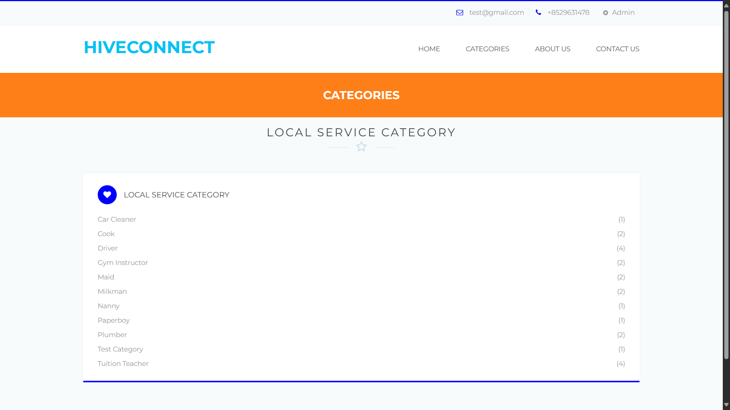

* + 1. **ADMIN LOGIN**

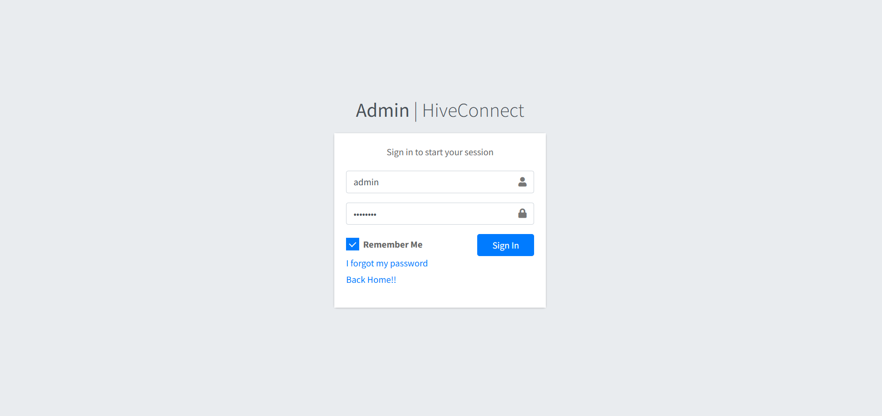

* + 1. **ADMIN DASBOARD**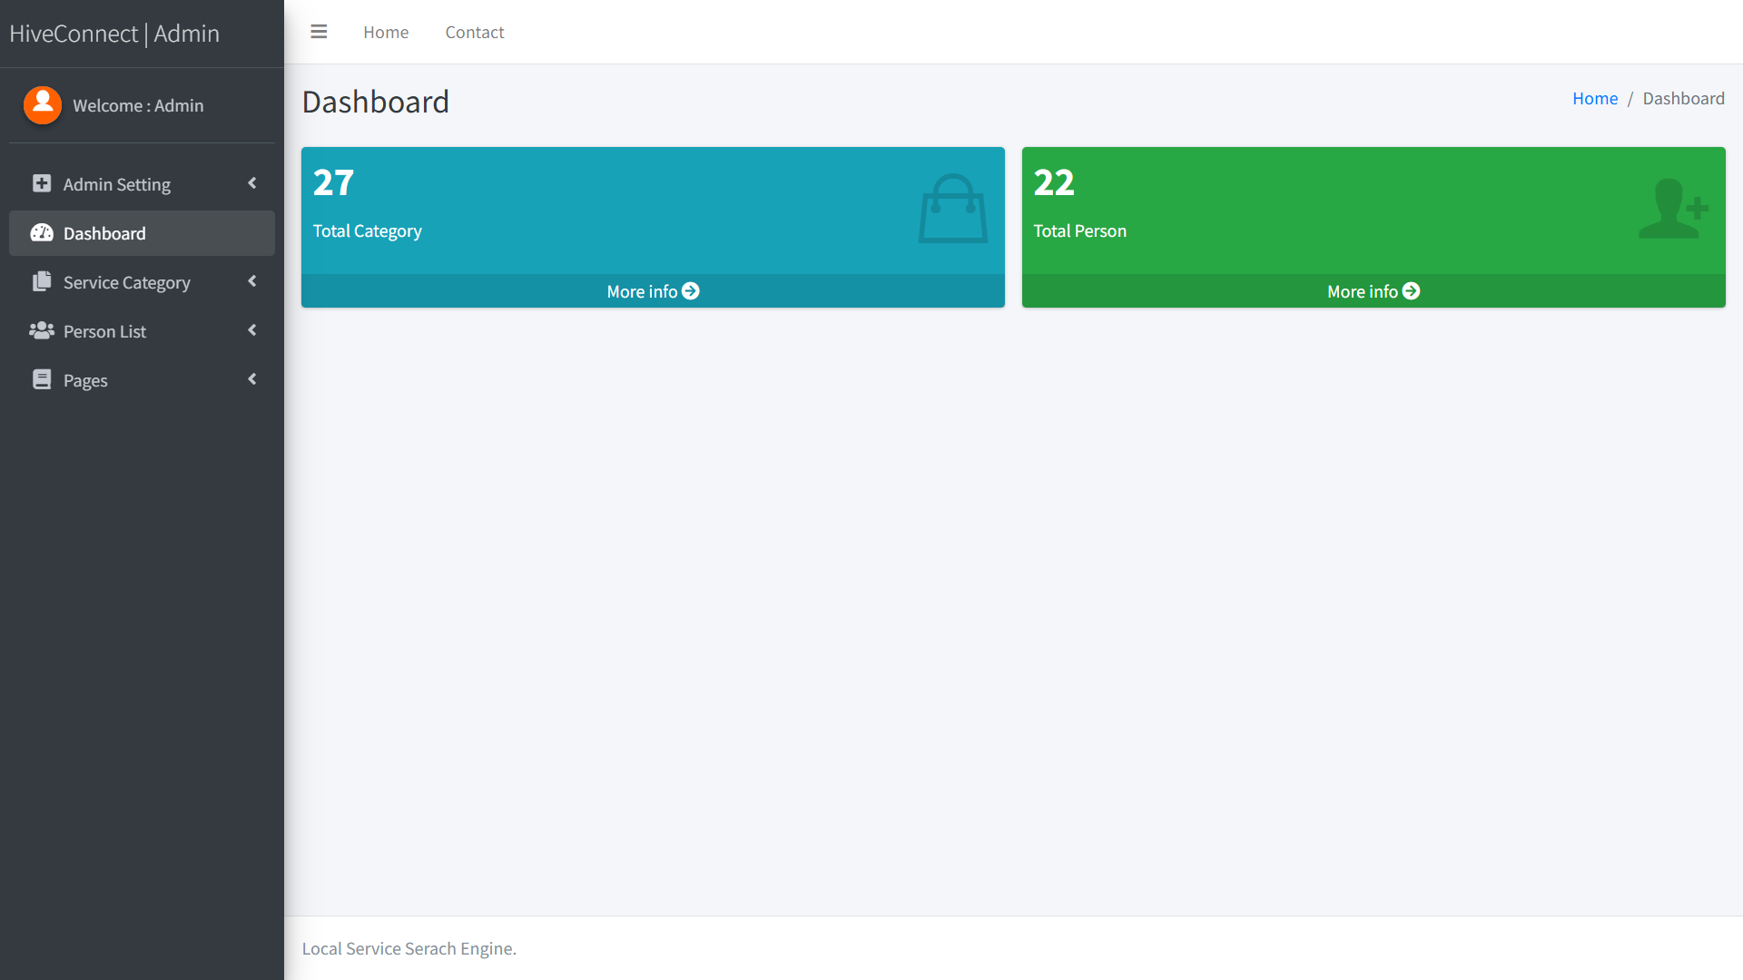
    2. **ADMIN MANAGE CATEGORY**

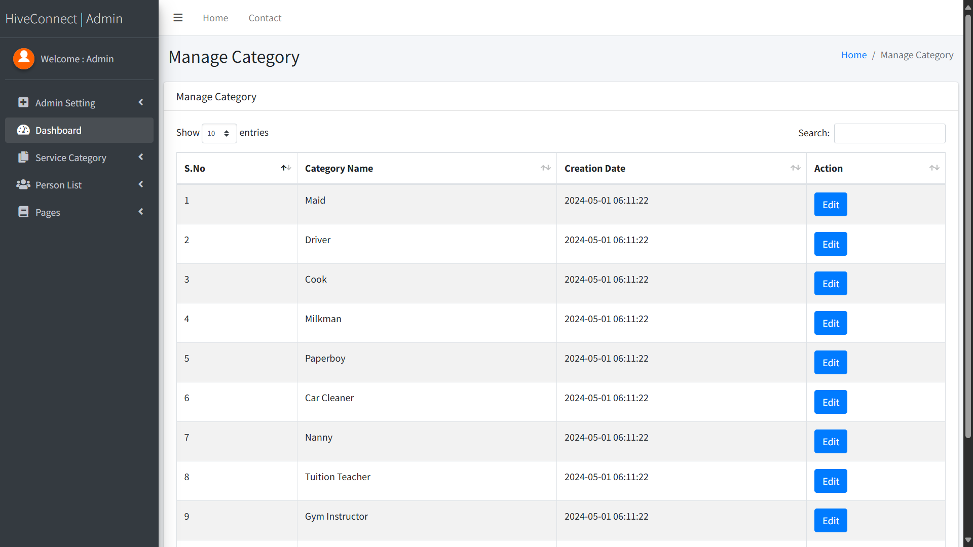

* + 1. **ADMIN MANAGE PERSON**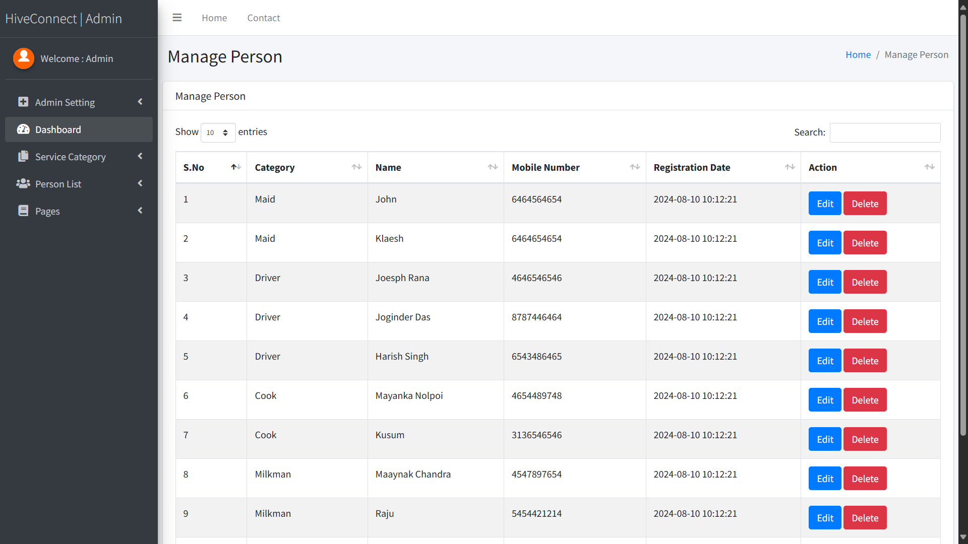

**CHAPTER 10**

**JOURNALS**

**REFERENCES**

1. Kaur, J., S., Ganjoo, P., Vaqur, M., & Joshi, K. A Review: Image Fusion using DCT and DWT. International Journal of Scientific & Engineering Research (IJSER)- Volume, 10, 702-707.
2. Joshi, K., Kashyap, D., Bisht, B., & Bagwari, A. GPS based Location Tracker: A Review. International Journal of Advanced Research in Computer and Communication Engineering (IJARCCE)- Volume, 8.
3. Kumar, R., Singh, G., Joshi, K. Emotion Recognition System using Local Binary Pattern. International Journal of Inventive Engineering and Sciences (IJIES) Volume, 5.
4. Joshi, K., Joshi, K, N., Diwakar, M. Image Fusion using Cross Bilateral Filter and Wavelet Transform Domain. International Journal of Engineering and Advanced Technology (IJEAT)- Volume, 8, 110-115.

**TEXT BOOKS**

1. Luke welling, Laura Thomson, **“PHP and MYSQL Web development”**, 3rd edition.
2. Kevin Tat roe, **“Programming PHP”**, 3rd edition, Pearson Education.
3. Andy Harris, **“PHP/MYSQL Programming for the absolute beginner”**.

**WEB REFERENCES**

1. https://www.w3schools.com/php/default.asp
2. https:/[/www.sit](http://www.sitepoint.com/)e[point.com](http://www.sitepoint.com/)
3. <https://www.php.net/>
4. ttp://www.mysqltutorial.org
5. https://sqlzoo.